

**Spring High School**

**FFA Handbook**

**2024 – 2025**

**FFA Advisors**

Courtney Musterman Patrick Fuchs Summer Kurtz

Claudia Zimmer

Revised August 2024

**Table of Contents**

**Welcome Letter………………………………………………………………………………………..…3**

**National FFA Fact Sheet………………………………………………………………….……………4**

**Spring FFA Introduction/Requirements…………………………………………….………….5**

**Travel Eligibility……………………………………………………………………………………………6**

**Code of Ethics………………………………………………………………………………………..…….6**

**Opportunities……………………………………………………………………………………..……7-10**

**Supervised Agricultural Experiences……………………………………………………….11-12**

**Official Dress…………………………………………………………………………………….……..…12**

**Livestock Facilities Contract…………………………………………………………..………13-18**

**Letter Jacket Requirements………………………………………………………………………..19**

**Student Contact Agreement………………………………………………………………….……20**

**Travel Agreement……………………………………………………………………….…………21-22**

**Handbook Acknowledgement form……………………………………………………………23**

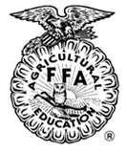

**Dear Spring FFA friends and family,**

Welcome to another exciting year with the Future Farmers of America (FFA)! As your chapter president, I am thrilled to embark on this journey with each of you.

Our FFA chapter is not just a club; it is a community of dedicated individuals who share a passion for agriculture, leadership, and personal growth. This handbook is designed to be your guide throughout the year, providing you with essential information about our activities, responsibilities, and opportunities.

As we dive into the year, I want to highlight three key components of our FFA experience: Supervised Agricultural Experiences (SAE), Leadership Development Events (LDE), and Career Development Events (CDE). I look forward to seeing you all join and engage in teams to develop your skills and expertise.

As we also work together let us be diligent in labor, just in our dealings, courteous to everyone and above all honest and fair in the game of life. Remember that your involvement is key to our collective success. Whether you are participating in competitions, contributing to community service, or attending meetings, your enthusiasm and commitment will help us achieve our goals.

I encourage you to take full advantage of the resources and opportunities available. Be proactive, ask questions, and most importantly, support one another. Together, we can make this year memorable and impactful.

Thank you for your dedication and hard work. Let’s make this year a great one!

Sincerely,

Alexia Tijerina President, Spring FFA.

**2024-2025 Spring FFA Officers:**

**President:** Alexia Tijerina **Vice President:** Adison Thompson

**Secretary:** Eliza Briscoe **Treasurer:** Trenton Santee

**Reporter:** David Garnica

***FFA makes a positive difference in the lives of students by developing their potential for***

***Premier Leadership, Personal Growth and***

***Career Success through Agricultural Education*.**

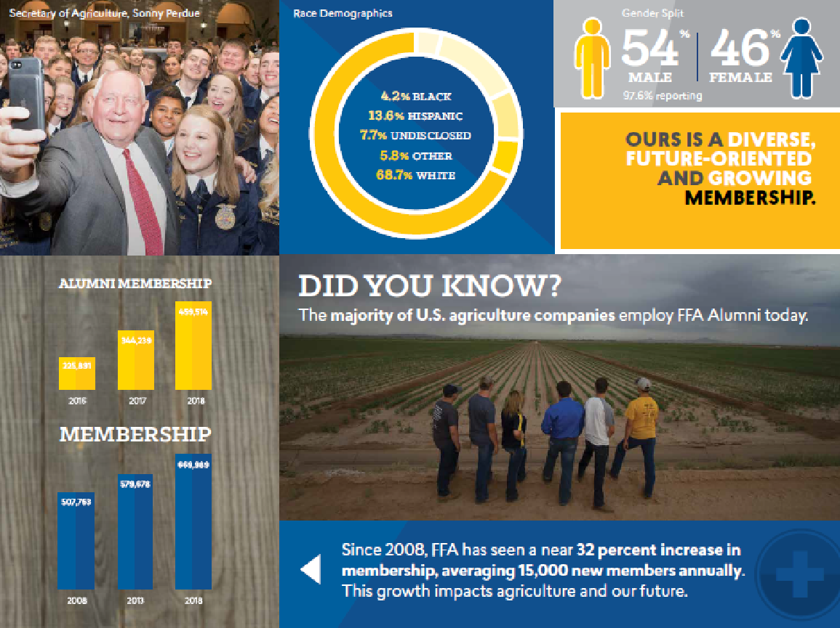

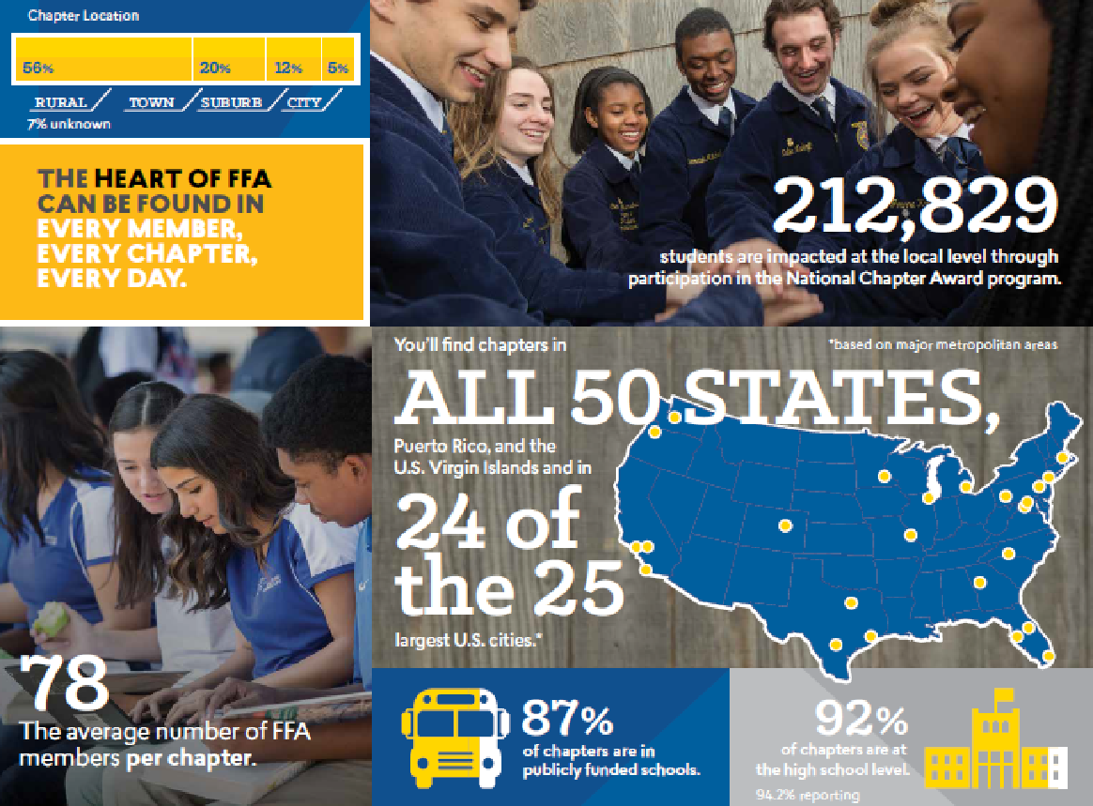

**Spring FFA**

As a student of the Spring ISD, you have the opportunity to join the largest youth led organization in the World, The National FFA! Your opportunity for success is wide open! And we have a lot of fun doing it!

**The Agricultural Education Mission**

Agricultural education prepares students for successful careers and a lifetime of informed choices in the global agriculture, food, fiber and natural resources systems.

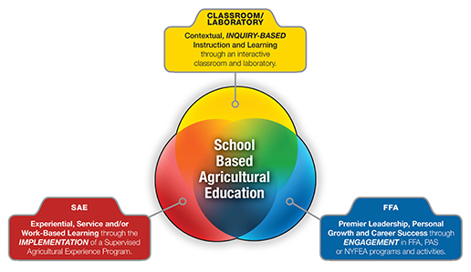

Agricultural education instruction is delivered through three major components:

* Classroom/Laboratory instruction (Contextual learning)
* Supervised Agricultural Experience programs (work-based learning)
* Student Leadership Organizations (FFA)

### Our programs are considered INTRA-CURRICULAR not extracurricular

**Membership Requirements**

* Be enrolled in an agriculture class (not required for junior membership)
* Pay Chapter dues
  + $25/year
* Participate in Seitz Fundraising (Meat and Desserts)
  + Must sell at least 10 items to participate in contests (buyout option of $50)
* Attend at least 4 meetings throughout the school year (banquet included)
  + Spring Livestock Show Exhibitors must attend at least 3 FFA meetings before the show. Parents will be required to attend a Spring Livestock Show meeting before registration.

**Social Media/Calendar**

* Follow us on our social media pages

Facebook: @springffa

twitter: @spring_ffa

For up-to-date event information, please refer to the Spring FFA website.

Spring.ffanow.org

**Spring FFA Eligibility Requirements**

In order to make sure that students are not missing out on a quality academic education, the Spring FFA Chapter has set forth minimum requirements for any member to be able to attend an activity. Please note that these requirements meet and exceed the District minimum requirements.

* Adhere to the “No-Pass, No-Play” policy of the Texas Education Agency. This is required by state law.
  + This policy states that all students participating in extracurricular activities must be passing all courses. **Students who fail any subject for the six weeks will be ineligible for a period of three (3) weeks.** Students may not participate in competition (livestock shows included) during the three week period following the failing grade. If the student is passing after the third week then the student becomes eligible for participation in competition after the fourth week (there is a one week grace period). If the student is still failing at the end of the three weeks, the student will remain ineligible until the end of the next three weeks or the next grading period.
* Passing ALL subjects at the time of any FFA event. This is regardless of the “No-Pass, No-Play” policy (even events that fall during the weekend or school breaks). Any student who is assigned to EC, Richey Academy (including pending), or is suspended at the time of an event is ineligible to participate.

Students that are not eligible, by the above standards, on the date of the event will not be allowed to attend the activity and will not be entitled to a refund of any monies paid for the trip.

**FFA Code of Ethics**

We will properly conduct ourselves at all times by:

1. Dressing neatly and appropriately for the occasion.
2. Showing respect for the rights of others and being courteous at all times.
3. Being honest and not taking unfair advantage of others
4. Respecting the property of others.
5. Refraining from loud, boisterous talk, swearing and other unbecoming conduct.
6. Demonstrating sportsmanship in the show ring, judging contests and meetings, and being modest in winning and generous in defeat.
7. Attending meetings promptly and respecting the opinion of others in discussion.
8. Taking pride in our organization, activities, supervised experience programs, exhibits and the occupation of agriculture.
9. Sharing with others experiences and knowledge gained by attending national and state meetings.
10. Strive to establish and enhance my skills through agricultural education in order to enter a successful career.
11. Appreciate and promote diversity in our organization.

**Substance Abuse Policy**

Members in Spring FFA are to follow all substance abuse policies as outlined by SISD. If a Spring FFA member is found with, or under the influence of illegal substances such as alcohol, tobacco, vapes, etc. they will have consequences from both the school district and our chapter. SISD policy and consequences are outlined in the student handbook. Spring FFA consequences are:

* **First Offense:** 3 week suspension from all FFA activities and events.
* **Second Offense:** 6 week suspension from all FFA activities and events.
* **Third Offense:** Removal from Spring FFA.

Members can rejoin FFA after they have been removed at the beginning of the following school year, but will be considered a probationary member.

**Opportunities through the FFA**

The FFA provides many opportunities for students to develop their premier leadership skills. As the largest high school youth leadership organization in the world, your membership in the FFA is specially designed to allow you many opportunities to develop “those qualities of leadership which an FFA member should possess.” Some of those opportunities include:

**Leadership Workshops**

The FFA has many opportunities for members to focus on their own leadership development. Leadership trainings can be found at National Convention, State Convention, Washington Leadership Conference in Washington, D.C., State Leadership Conferences, and Chapter Officer Leadership Training. All workshops and conferences are interactive and designed specifically to enhance your personal leadership skills. *(Scholarships may be available to attend various leadership workshops.)*

**Chapter Leadership**

The FFA is a student organization, completely run and managed by students for more than 75 years. As a member of this organization, you have the chance to take on a leadership role and plan activities for the chapter. There are three levels of chapter leadership available for you to participate in:

* As a committee member, you have the opportunity to help decide the specific details of a chapter activity or event. All members are part of a committee.
* As a committee co-chair, you will have the chance to run a committee and develop the chapter activities throughout the year. Complete the committee preference part of your membership application and indicate an interest in being a co-chair.
* As a chapter officer, you have the chance to plan and conduct the entire chapter program of activities for an entire year. Applications and interviews are completed before the annual FFA Recognition Banquet.
* Hands-on leadership provided through the FFA can truly be a stepping stone to a successful life. Successful chapter leadership can also open more doors in the FFA for you as well. Upon completing a chapter officer position, you may choose to set your sites on becoming a Regional, State, or National FFA Officer.

**Leadership Development Events (LDE’s)**

Leadership Development Events focus on creating situations for members to demonstrate their abilities in public speaking, decision making, communication and their knowledge of agriculture and the FFA organization. Spring FFA members have the opportunity to join the following LDE teams.

* **Junior & Senior Quiz Team:** Students will take an exam testing knowledge of Parliamentary Procedure FFA knowledge including history, facts, business structure, leadership and programs is given to individuals. Quiz teams can be made of 3 or 4 members.
* **Junior & Senior Creed Speaking:** A member presents the FFA Creed from memory and answers questions about its meaning and purpose. This event is just one way to boost self-confidence, earn recognition, and develop powerful, organized and professional communication skills.
* **Junior and Senior Agricultural Skills Demonstration:** A team of 3-5 members performs an actual demonstration of an agricultural skill including anything in the Agricultural Science and Technology curriculum using effective public speaking and communication methods.
* **FFA Broadcasting:** A team of 3 members presents an informative radio program covering one or more agricultural subjects that is current in nature and local in content.  The contest assumes that the chapter has a regularly scheduled radio program once each month over a local station.
* **Chapter Conducting:** Teams conduct a mock chapter meeting to demonstrate knowledge of basic parliamentary law and the use of correct parliamentary procedures. At the conclusion of the meeting, team members are asked questions regarding parliamentary law
* **Agricultural Advocacy:** This contest will be designed to inform the general public and consumers about the importance and value of the agriculture industry and how agriculture impacts human lives.  Agricultural Advocacy teams will be made up of 3-5 members from the same chapter.
* **Agricultural Issue Forums**: A team of 3 to 7 students research and analyze a current agricultural issue, create a portfolio and develop and deliver a presentation that stresses both pros and cons of their selected agricultural issue. Members defend their findings and answer judges’ questions.
* **Job Interview:** At the competition, each member submits their resume, completes a job application for an agricultural position on site and participates in an interview via telephone, in person one-on-one and with a panel of possible employers.
* **Public Relations:** A team of 2 to 4 members develops and presents a 5-8 minute program informing a specified target audience regarding the Texas FFA and what it represents. The presentation is developed assuming the target audience has no knowledge of the FFA. Members are asked questions in response to their program following the presentation.

**Career Development Events (CDE’s)**

Career Development Events build on what is learned in agricultural classes and encourage members to put their knowledge into practice. These events are designed to help a member prepare for a career in agriculture by testing and challenging the student's technical, leadership, interpersonal and teamwork skills as well as their knowledge of the subject matter. Spring FFA members have the opportunity to join the following CDE teams.

* **Wildlife and Recreation Management:** A team of 3 to 4 students demonstrate and identify plant species, proper habitat management practices, safety procedures, game laws, management techniques as well as compass and pacing skills.
* **Floriculture:** This event requires students to identify plant materials, tools, and pests common to the industry, demonstrate knowledge and understanding of scientific principles and management practices applied in the industry via a written exam, make observations, draw conclusions, and utilize higher order thinking skills in problem solving situations. Floriculture teams are made up of 3 to 4 members.
* **Livestock:** A team of 3 to 4 members demonstrate desirable traits of livestock today by observing individual animals and evaluating, based on industry standards, a class of livestock in the species of steers, heifers, lambs, goats, and pigs.
* **Poultry:** This CDE tests members' knowledge on poultry basics, carcass grading, poultry processed products, egg grading and live bird evaluation. Team consists of 3 to 4 members.

**\*\*Other CDE contests may be considered based on student interest. For more information visit texasffa.org/cde\*\***

**Public Speaking Events**

Speaking Development Events are designed to develop the ability of all FFA members to express themselves on a given subject. Students are encouraged to develop their communication skills and learn to formulate their remarks for presentation in a variety of situations. From writing an agricultural speech in the prepared speaking event, to thinking on your feet with the extemporaneous speaking event, FFA speaking events can truly develop your confidence and ability to lead through your words.

**Agricultural Mechanics**

FFA Members may participate in Ag Mechanics Shows. Projects to be built in the shop will be approved by the Ag Teacher/FFA Advisor at their sole discretion. All approved projects built in the shop under the direction of the Ag Teacher/FFA Advisor will be entered at Ag Mechanics shows through the Spring FFA Chapter.

Quality of workmanship, type of project, and student participation and attitude will be considered when approving projects for major show entries. Even though a project was preapproved for construction, it can be denied Ag Mechanics show entry if any of the above factors are found to be deficient.

Students to be selected for Ag Mechanics show participation should maintain good behavior and not exhibit persistent disciplinary problems. Any student that has displayed behavior problems will have a meeting with the advisors to discuss behavioral concerns. Inappropriate behavior will constitute removal for future Ag Shows. Removal of a student from the list of show participants will be at the sole discretion of the Ag Teacher/FFA Advisor with administrative approval. Such removal can occur at any time during the construction of projects.

Students exhibiting projects must be present at their assigned projects for the entire duration of time as outlined by the Ag Teacher/FFA Advisor. Any departure from this schedule may result in removal from the project for further shows. Any behavior at the show deemed inappropriate may result in immediate removal from the project exhibition at the current show. Such removal will be at the sole discretion of the Ag Teacher/FFA Advisor.

With time constraints and shop space some projects will have a higher priority than other projects. Students with prior experience will precede those that are new to the program. It will be left to the discretion of the Ag Teach/FFA Advisor to determine priority. Depending on the amount of participation, some students and projects may not be completed for all shows.

**Livestock Shows**

FFA and Jr. FFA Members may purchase, own and show animals under Spring FFA. Members should understand it is their responsibility to purchase, house, and care for their animals. The Ag Teacher/FFA Advisor will sign entry cards and check projects. Members may use Ag Facilities to house animal project as long as they sign and agree to rules set by the district.

***\*\*\*All students exhibiting a livestock project at a major stock show must complete the Quality Counts Program. The advisor in charge of your specific species will be your contact for information regarding this program.\*\*\****

**Supervised Agricultural Experiences**

The Supervised Agricultural Experience (SAE) is a required component of a total agricultural education program and intended for every student. Through their involvement in the SAE program, students are able to consider multiple careers and occupations, learn expected workplace behavior, develop specific skills within an industry, and are given opportunities to apply academic and occupational skills in the workplace or a simulated workplace environment. Through these strategies, students learn how to apply what they are learning in the classroom as they prepare to transition into the world of college and career opportunities.

**To further define the types of SAE programs available to and appropriate for students of school-based agricultural education, refer to the following examples:**

**Foundational**

Foundational SAEs are appropriate for all agriculture students. This SAE activity is usually beginner level, short term and designed primarily to help students become literate in agriculture and/or become aware of possible careers in the AFNR career cluster. Foundational SAEs should help students create a larger more focused SAE.

**School-Based Enterprise**

This type of SAE is student managed, can be entrepreneurial or placement and takes place in a school setting outside of regularly scheduled class time. The project needs to provide goods and services that meet the needs of an identified market and should replicate the workplace environment as closely as possible. Examples of school based enterprises may include, but are not limited to, cooperative livestock raising in a school facility; managing or working in a school garden, a land lab or a greenhouse; agricultural research done at the school; agricultural equipment fabrication or equipment maintenance services done using school facilities; or managing or working in a school store.

**Ownership/Entrepreneurship**

Students with an ownership/entrepreneurship type SAE own the enterprise, equipment and supplies, make the management decisions and assume the financial risks to produce a product or provide a service. All products or services must be agriculturally related. A few examples would include raising and selling animals or crops, building and selling agricultural equipment, buying and reselling feed, seed or fertilizer, owning a pet care business or a business that programs and installs computer equipment in tractors.

**Placement/Internship**

Placement/Internship programs involve the placement of students in agriculture, food or natural resources-related businesses to provide a "learning by doing" environment. These experiences may be paid or unpaid. Examples would include working on a farm or a ranch, in a farm supply store or a food testing laboratory or in an agriculturally related non-profit organization.

**Research**

In a research SAE students plan and conduct major agricultural experiments using the scientific process and discover new knowledge. As part of the research, students verify and demonstrate or learn about scientific principles in agriculture. Research SAEs can be entrepreneurial or placement. Research SAEs can be conducted alone or cooperatively with other students or mentors/employers. Examples would include conducting research on the most efficient feed supplements for livestock or the best fertilization methods in plants. Research could also be done to study consumer reactions to agricultural products or to determine the best method of welding to hold together a plow.

**Service-Learning**

A student-managed service activity where students are involved in the development of a needs assessment, planning the goals, objectives and budget, implementation of the activity, promotion and evaluation of a chosen project. It may be for a school or community organization. The student(s) are responsible for raising funds for the project (if funds are needed). A project must not part of an ongoing chapter project, or community fundraiser. Service-learning SAEs may be individual or a small group effort

**Official Dress**

The FFA Jacket is the most recognizable symbol of the organization. As a member, one of your responsibilities is to ensure its proper use. Specific guidelines are outlined below.

1. The jacket is to be worn only by members.
2. The jacket should be kept clean and neat.
3. The jacket should have only a large emblem on the back and a small emblem on the front. It should carry the name of the State Association and the name of the local chapter, district or area on the back and the name of the individual and one office or honor on the front.
4. The jacket should be worn on official occasions with the zipper fastened to the top. The collar should be turned down the the cuffs buttoned.
5. The jacket should be worn by members and officers on all official FFA occasions where the chapter or state association is represented. It may be worn to school and other appropriate places.
6. The jacket should only be worn to places that are appropriate for members to visit.
7. School letters and insignia of other organizations should not be attached to or worn on the jacket.
8. When the jacket becomes faded and worn, it should be discarded or the emblems and lettering removed.
9. The emblems and lettering should be removed if the jacket is given or sold to a non-member.
10. A member always acts like a lady or gentleman when wearing the jacket.
11. Members should refrain from the use of tobacco and alcohol while wearing the FFA jacket or officially representing the organization.

All chapter degree, officer and award medals should be worn beneath the name on the right side of the jacket, with the exception that a single State FFA Degree charm or American FFA Degree key should be worn above the name or attached to a standard key chain. No more than three medals should be worn on the jacket. These should represent the highest degree earned, the highest office held and the highest award earned by the member.

**2024 - 2025**

**Spring ISD Agriscience Facility Rules**

The purpose of the Spring ISD Agriscience Facilities are to provide an extension to the classroom for Spring High School, Westfield High School, Carl Wunsche Sr. High School, Dekaney High School, and Roberson Middle School agriculture science students to utilize in their Supervised Agricultural Experience Projects (SAEP).

As the advisors of students’ SAE projects and advisors of the Spring FFA, Westfield FFA, Wunsche FFA, and Dekaney FFA, the agricultural science teachers (AST’s) are here to ensure an educational opportunity for students, along with the image, character, and integrity of the Spring ISD FFA Chapters.

In order for all parties to best utilize the agriscience facilities, several rules and expectations must be followed. The AST’s and school administrators will monitor the facilities to ensure the rules and expectations are being followed.

Any person who would like to discuss a barn rule or situation that they feel needs attention will discuss that concern with the teacher that supervises their species.

The Spring ISD AST’s reserve the right to make decisions concerning the agriscience facilities, the projects, and the rules for the agriscience facilities, as needs or situations arise during the year.

The Spring ISD Agriscience Facilities are Spring ISD facilities and therefore all rules and regulations located in the student handbook apply and will be enforced.

Each April the Spring ISD AST’s will revisit and update the barn rules. Any students who are currently housing their animals at an agriscience facility will be required to sign and return the new Spring ISD Agriscience Facilities rules by May 1st of that year. If the 1st falls on a Saturday or Sunday the student must submit the signed Agriscience Facilities rules on the Friday prior to May 1st.

Spring Independent School District, Spring High School, Westfield High School, Carl Wunsche Sr. High School, Dekaney High School, Roberson Middle School, Spring High School AST’s, Westfield High School AST’s, Carl Wunsche Sr. High School AST’s, Dekaney High School AST’s, Roberson Middle School AST’s, and their supporters are not responsible for any damages or losses incurred to personal property of the students, parents, guests, etc. at the Spring ISD Agriscience Facilities.

In order to ensure the safety of all students, parents, legal guardians, animals, and teachers that utilize Spring ISD Agriscience Facilities, a strict time frame will be set for the facilities to be used. The Spring ISD Agriscience Facilities will open at 5:00 am and will close at 9:00 pm. Since the Westfield High School Agriscience Facility, Wunsche High School Agriscience Facility, and the Dekaney High School Agriscience Facility do not have barn monitors on the premises, random barn visits by the respective Spring ISD AST’s, as well as camera monitoring, will be used to enforce this rule. If the barn hours are not adhered to, the respective Spring ISD AST’s will issue notifications of infractions.

**Student Requirements for Housing at the Facility**:

* Students must be enrolled in a Spring ISD School. (can be elementary, middle, or high school)
* Students must be a paid Spring ISD FFA member, in good standing with the organization (this includes holds from the previous years), to exhibit animals through a Spring ISD FFA chapter and to house animals at a Spring ISD Agriscience Facility.
* The Spring ISD Agriscience Facility rules must be signed and returned before students will be issued a pen, given keys/code and allowed to move animals into the barn.
* Eligibility — Per the SISD Student - Parent Handbook:
  + A student who receives at the end of a grading period a grade below 70 in any academic class—other than an Advanced Placement (AP) or International Baccalaureate (IB) course; or dual credit course in English language arts, mathematics, science, social studies, economics, or language other than English—may not participate in extracurricular activities for at least three school weeks.
  + A student who receives special education services and who fails to meet the standards in the individualized education program (IEP) may not participate for at least three school weeks.
  + A student is allowed in a school year up to 10 absences not related to post-district competition, a maximum of 5 absences for post-district competition prior to state, and a maximum of 2 absences for state competition. All extracurricular activities and public performances, whether UIL activities or other activities approved by the board, are subject to these restrictions.
* Any student that is ineligible for the Spring Livestock Show has 72 hours, from the time of ineligibility notification, to remove their animal(s) and belongings from the facility.
* This pertains to market animals only, as they are terminal.

**Animal Requirements for Housing at the Facility:**

* Only show animals that are validated, registered, or purchased for a show in the current school year are allowed to be housed at a Spring ISD Agriscience Facility. All animals must be shown & exhibited solely under the FFA chapter that is assigned to each facility at any show that it is entered into. For example, only Spring FFA members are permitted to house their animals at the Spring FFA Agriscience Facility, etc.
* If you are keeping any breeding animals at the Agriscience Facility, you will need to provide registration papers (large animals) showing the exhibitor as the sole owner of the animal. For breeding poultry you will need to provide the Advisors with a copy of

your Pullorum Typhoid certificate.

Breeding Livestock Permitted at the Facilities are:

* Breeding Heifers (offspring may share a pen until 5 months)
* Breeding Gilt (offspring may share a pen until 6 weeks)
* Breeding Bucks (rabbit)
* Breeding Does (rabbit)
* Cockerel (chicken)
* Pullet (chicken)
* Cock (chicken)
* Hen (chicken)

**Teacher Approval Prior to Purchase:**

* Any individual wishing to have an animal or crop as their SAEP must first have approval for each species from their respective Spring ISD AST.
* The approval for all animal purchases by students for an SAEP, whether housed at the Spring ISD Agriscience Facility premises or off these premises, must go through the respective Spring ISD AST’s PRIOR to their arrival. Reasons for non-approval, may be, but are not limited to: health, structural quality, seller, or animal breed.

**Utilization of Pens at Facility:**

* Decisions for extra pens will be made at the discretion of the respective Spring ISD FFA Advisors that are in charge of each facility.
* Each student is limited to **two (2)** projects from the same species, with a maximum of **4** projects total on the grounds of the Spring ISD Agriscience Facility. Rabbits and poultry will not be counted by individual animals, rather by the number of pens that are occupied.
* Students **MAY NOT** alter pens for any reason without approval from Advisor.
* Due to FERPA and privacy violations, no one shall be permitted to install personal cameras.

**Locks at the Barn:**

* All gate locks will be provided by Spring ISD and the codes/Keys will be given to the students after they have paid the pen rent.
* **NO PERSONAL LOCKS** are allowed to lock any pens or feed at the Spring ISD Agriscience facilities. You may lock your personal belongings (tack boxes, show boxes etc.)

**Behavior of Individuals at Facility:**

* Individuals, whether sellers, breeders, relatives/friends of students, etc., that interfere with the instructional process, verbally or physically assault/threaten any person(s) or otherwise undermine the authority of the respective Spring ISD AST’s, will receive a notice of Ban form. Parents/visitors should not address other students at the Barn and should reach out to the AST's to address all matters.
* **Only Spring ISD FFA students or parents/legal guardians of housed animals will be allowed at each Spring ISD Agriscience Facility. All others without permission will be considered trespassing**.
* In the case that a guest is asked to come to the barn facility by a parent or student, the respective Spring ISD AST’s must be notified **2 days prior** to the guest coming to the facility. Should the respective Spring ISD AST’s deem it necessary, those teachers will be accompanying the guest and the parent/student at the barn. Spring ISD AST’s reserve the right to deny any request to have a guest at the barn.
* No Loitering! Feed and care for your animal as necessary and then leave the project center. Any issues that arise or damages that the property or animals incur by the student, family of the student, or guest of the student will be deemed the student and their guardian’s responsibility.
* The gate is to be closed and locked at all times. If you go through the main gate of the barn, and it is not immediately closed, action will be taken and notifications of infractions will be issued. The gate is for the safety of everyone’s animals. Disregarding this rule will not be tolerated.
* According to Spring ISD, vandalism will not be tolerated! Any vandalism will result in immediate eviction of all animals and items that the individual owns.
* Users of the facility are not allowed to bring any domesticated animals (i.e., dogs, cats, house pets, etc.) on the Spring ISD Agriscience Facility grounds unless approved by an Advisor of the respective Spring ISD FFA chapter. If one is brought onto the premises and damages to an animal or property occurs, the individual who brought it will be responsible for the monetary damages as determined by the owner of the animal or property. If the property belongs to a Spring ISD FFA chapter, the respective Spring ISD AST’s will determine the value of the property.
* Any changes made to the barn, pens, or property must have prior approval from the AST’s.

**Proper Care of Animals/Pens:**

* Students shall be financially responsible to ensure the proper care of their animal(s). This includes, but is not limited to: purchasing equipment (such as blowers, combs, brushes, water hoses, clippers, feed pans, buckets, fans, heat lamps, etc), grooming supplies (adhesives, shampoos, conditioners, paint, etc), feed, medicines, supplements and medical expenses to properly care for their project. Spring ISD FFA chapters are not responsible for providing the needed items for a student’s project.
* Animal health requires that feces (animal waste) be dumped in the approved container (dumpster) and deceased animals taken off of the premises. Anyone reported of inappropriately dumping animals or waste will receive a notification of infraction. Dumping in trash cans, outside your pen, or around the farm will not be tolerated. A Spring ISD AST (in charge of the respective facility) should be notified once the dumpster reaches ½ full capacity.
* Students/parents must provide clean water and feed DAILY. Feeding should occur twice a day unless the animal is on a self-feeder (i.e., market barrow).
* The student is responsible for cleaning and maintaining the project area (e.g. pen, alleys, barn) at all times. The pen should be cleaned daily to eliminate the possibility of parasites and other illnesses being spread in the barn. If the pen is not cleaned daily, the respective Spring ISD AST’s will issue notifications of infractions as they deem necessary.
* No animal shall be abused in any way. Examples could include, but are not limited to: beating, mutilation, withholding feed/water, withholding medical attention, using illegal drugs, keeping the animal in unsanitary conditions, etc. If the animal is not being properly cared for, the respective Spring ISD AST’s will issue notifications of infractions. However, if the severity of the situation demands immediate attention (beating, etc.), Spring ISD Police Department will be notified, the offender will be removed from the premises (and banned until further notice), and the animal will be surrendered to the respective Spring ISD FFA chapter.
* No shots, injections, implants, supplements or changes to feed are to be administered without written permission from the respective Spring ISD FFA AST’s.
* The use of extension cords is strongly prohibited, unless approved by the respective Spring ISD FFA Advisor prior to use. This includes approval of the type of extension cord, as well as the method of fixing the extension cord for use. If extension cords are used without prior approval or if extension cords are used that are not deemed safe, the respective Spring ISD AST’s will issue notifications of infractions.
* Students/parents/legal guardians may use one appliance per pen. However, before appliances may be utilized, the appliance must be approved by the respective Spring ISD AST’s. If appliances are used with prior approval or more than one appliance is utilized per pen by the student/parent/legal guardian, the respective Spring ISD AST’s will issue notifications of infractions.

**Emergency Situations:**

* In emergency situations (fire, hurricane, etc.), all able-bodied students shall assist any and all handicapped persons to the entrance/exit gate. Then, if there is not an imminent danger, they will systematically release the animals from their pens, if needed.
* In the case of an animal emergency, contact the respective Spring ISD FFA Advisor FIRST and he/she will advise if a veterinarian is necessary. However, if you are in danger, contact Spring ISD Police first! If your animal is in danger of dying, contact an emergency veterinarian first!
* In the event of inclement weather, the FFA advisor will provide explicit instruction and the students are expected to adhere to those instructions completely.

**Inclement Weather**

* In the event of freezing conditions, water will be drained and shut off and will remain off until all threat of freeze passes
  + Animals should have heat lamps and a hay windbreak to assuage the cold weather conditions
  + A rest area tack room will be available for students
  + Students that have self-dispensing feed/water containers may avoid barn visits
* In the event of flooding students should only go to the barn if they can do so safely. If a student is unable to safely get to the barn the Ag advisor should be notified. Students should prepare for conditions by having feed on site so animals can be fed.

**Removal of Animals from the Facility (voluntarily and involuntarily):**

* Any evicted animal is to be removed within three (3) days—72 Hours—of eviction notice or the animal will become the property of the exhibitor’s respective Spring ISD FFA Chapter and it will be sold. The income money from this sale will go into the respective Spring ISD FFA chapter’s Pen Maintenance account. Income from the sale will not defer any pen maintenance fees, fines, or fees that are due. If a student and their animal are evicted from a Spring ISD Agriscience Facility, the student forfeits any opportunity to utilize any facility or raise an animal in a Spring ISD FFA chapter for the remainder of their time in Spring ISD.
* If an animal dies while housed at the barn it is the responsibility of the student to remove the animal and dispose of it the proper way. If you are unable, please contact Cardoza at 281-446-9692.
* The student is to remove all projects and equipment from the barn and clean their pen within one week —7 days—after the Spring Livestock show. The Spring Livestock show will be considered finished, at the conclusion of the auction. On day 8, the animal will become property of the exhibitor’s respective Spring ISD FFA chapter and sold at auction. The income money from this sale will go into the respective Spring ISD FFA chapter’s Pen Maintenance account. All market animals whose target show was the Spring Livestock show must be removed, including those animals owned by students that failed. If you wish to keep equipment at the barn over the summer, you must state so in writing including where the equipment will be stored. All equipment left will become the property of the student’s respective Spring ISD FFA chapter. Leaving equipment in a pen does not reserve the pen for subsequent years. The respective Spring ISD FFA AST’s are the only persons who assign pens.
* A $50 hold fee will be put on a student’s account if their pen is not cleaned within 7 days of the animal being removed from the barn.

**Pen Maintenance Fees:**

* The student or family will pay pen maintenance fees for using the Spring ISD Agriscience Facilities in full at the time of the arrival of the animal. In the case of a hardship, it is at the discretion of the respective Spring ISD AST’s to set up payment plans with the student and parent. All prices below are per head, except poultry and rabbits which are per pen. In the case that goats or lambs are doubled up (2 per pen), per the respective Spring ISD AST’s, the pen maintenance fee will not be divided. If you desire to keep your pen while sending a breeding stock animal to be bred, you must pay pen rent while the animal is away. Otherwise, your pen may be subject to use as the respective advisors deem fit. Any animal that is on the premises for 24+ hours will pay pen rent for the entire month.
  + For students on hardships, all rent and/or fees must be paid prior to a show in order to show at a show through the student’s respective Spring ISD FFA chapter. For example, if a student is showing at Harris County Fair, the student must have all pen maintenance fees paid for the prior months in order to be allowed to show.
  + Empty pens will not be utilized as tack pens due to the limited amount of space we have. If room for tack cannot be located, the respective AST’s will assign space for the tack, as they deem necessary.

|  |  |
| --- | --- |
| SPECIES | COST |
| Cattle | $15.00 /month |
| Lamb | $10.00 /month |
| Goat | $10.00 /month |
| Swine | $10.00 /month |
| Chickens | $10.00 /month |
| Turkeys | $10.00 /month |
| Rabbits | $10.00 /month |

**Terms and Conditions**:

* If the student/parent/guest fails to abide by any of the above-mentioned rules, actions can be taken to remove their animal, withhold payment for projects, issue a fine, and/or ban future Spring ISD Agriscience Facility privileges. Disciplinary action may also result from failure to comply with these rules.
* Procedures for notice of eviction:
  + Written notice of infraction and verbal warning issued.
  + Written notice of infraction and parent contact.
  + Written notice of infraction & eviction of project.
  + Pen maintenance fees will still be due on any animal evicted from the Spring ISD Agriscience Facility for the months that it was there.
  + If a student and their animal are evicted from a Spring ISD Agriscience Facility, the student forfeits any opportunity to utilize any facility or raise an animal in a Spring ISD FFA chapter for the remainder of their time in Spring ISD.

Refer to **Removal of Animal from Facility** section on pages 5-6.

* Procedures for Banning an individual from a Spring ISD Agriscience Facility:
  + When a situation is witnessed or brought to the FFA advisors for that Agriscience Facility, a committee comprised of one Advisor from the campus involved, the Agriculture Career Cluster Coordinator and The CTE Director/Coordinator will determine if a notice of ban is necessary.
    - Spring ISD reserves the right to remove any person(s) from Spring ISD Agriscience property for misconduct at the sole discretion of Spring ISD administration officials without appeal.
    - Any person can be declared banned by the ban committee as stated above through a written notification at which time they will no longer be allowed to enter the identified Spring ISD Agriscience property for a

duration up to and including life at the sole discretion of the ban committee.

* Any person so such labeled found on Spring ISD property will

be charged with trespassing.  Any personal property still located on Spring ISD Agriscience property after written notice is given must be removed within 7 days or is forfeit to Spring ISD.  For the purpose of property removal, said person may only enter with police escort.

**\*\* STUDENTS WILL BE REQUIRED TO HAVE A COPY OF THE SIGNED BARN RULES ON FILE WITH SPRING FFA PRIOR TO BRINGING A PROJECT INTO THE SPRING FFA BARN\*\***



**Student Contact**

During the course of the school year, it may be necessary for a sponsor/coach to contact your child via their cell phone to apprise him/her of important information and vice versa. Text messaging is an easy way to send and receive information fairly quickly, but a phone call may be necessary also. We would like to have your permission to use this form of communication during the scheduled events or activities that your child is participating in during the year.

As a rule, we have advised staff that all contact should occur between the hours of 7:00 a.m. and 8:00 p.m. However, there may be situations that require a school employee to text outside of that time frame. For instance, if students are scheduled to leave prior to 7:00 a.m. and there is a schedule change (i.e. rain delay or cancellation), a sponsor or coach would notify the student as soon as information becomes available even if it is before 7:00 a.m.

Should you ever be concerned about the nature of any contact, please contact the campus principal immediately.

If you have any questions about this matter, please do not hesitate to call at 281-891-7000

Courtney Musterman, Patrick Fuchs, Summer Kurtz, Claudia Zimmer

**Students Name: ___________________________________________________________________________**

**Parent Name: _____________________________________________________________________________**

**Parent Signature_________________________________________________ Date ______________________**

__________________________________________________________________________________________

**RETURN THIS PAGE SIGNED**

**Spring FFA Travel Outline**

**Itinerary:** Before each trip an itinerary will be emailed out to parents. This will list the daily activities and estimated times of the activities.

**Safety Precautions:** The Advisors will take the following safety precautions before and during each Spring FFA trip.

* Field trip forms will be collected with medical information included
* Bag checks will be conducted prior to leaving on the trip
* Curfew for students will be set each night (An advisor will make a sweep of the room immediately before curfew)
* Tape will be placed over the door jam and signed by an advisor (The tape will be removed in the morning, if there is an emergency the students may break the tape)

**Student Behavior:** The students will be upheld to a high standard. They will be representing Spring ISD, Spring High School and Spring FFA. The three levels of behavior infractions are listed below:

* Level 1

- The student disobeys a request from the Advisor or Chaperone.

- The student uses inappropriate Language.

- The student is out of dress code.

* Level 2
* The student allows unauthorized visitors into their room (ex: boys in girl room or girl in boy room)
* The student incurs charges to their room (damages, phone calls, room service, movies, internet, etc.)
* Level 3 **(Automatic removal from trip-Parent will need to pick student up)**
* The student is in possession of or is suspected of using drugs/alcohol
* The student is involved in a physical altercation

**Consequences:** The consequences will vary depending on the level of the offense. Example consequences include, but are not limited to:

* Reprimanded by the Advisor
* Office Referral
* Immediate removal from the trip- **parent will be expected to pick the student up immediately.**

**Spring FFA Travel Outline**

**Acknowledgement Form**

***I have read the Travel Outline for Spring FFA***.

_________________________ _____________________________

Parent Name Parent Signature

_________________________ _____________________________

Student Name Student Signature

***This form needs to be turned in prior to the date of the trip.***

**RETURN THIS PAGE SIGNED**

Chapter Handbook Acknowledgement form

**2024-2025 Spring High School Agricultural Science/FFA Department Student & Parent Information Book Acknowledgement**

**STUDENT INFORMATION:**

Name (Printed) _________________________________ Grade _____ ID _________ Cell Phone _____________________________ School: __________________

Address ___________________________________ City ____________ Zip _______

*I am aware of the FFA opportunities available through review of the handbook in class.*

**Student Signature _____________________________________ Date____________ PARENT/ GUARDIAN INFORMATION:**

**1. Name**________________________________ Relationship ___________________ **Work__________________ Cell _________________Email_____________________**

**2. Name**________________________________ Relationship ____________________ **Work__________________ Cell _________________Email_____________________**

**Photographs:** Please check one of the following statements.

____ *The agricultural department* ***MAY*** *use pictures of my child participating in activities on the Spring ISD, Spring HS, and Spring FFA web pages.*

____ *The agricultural department* ***MAY NOT*** *use pictures of my child participating in FFA activities on the Spring ISD, Spring HS, and Spring FFA web pages.*

***The above information is accurate and approved by me, the parent/guardian. I understand that I can find Agriculture program information and guidelines online. I understand Agriculture teachers may contact my child via cell phone or text with program information if they are involved in extracurricular FFA activities, including but not limited to, raising livestock or traveling for competition.***

**Name _____________________ Signature________________________ Date______**